Edit Simultaneously - Design Doc

**Status:** Under review

**Created:** Nov 03, 2022

**Last Updated:** Nov 08, 2022

**Authors:** Ana Levit, Tal Ben-Zur, Lior Mathan

**Approvers:**

**Additional Links:** [[Shared Doc req.pdf](https://drive.google.com/file/d/1fKQkn8He63isOvf0L3mgw0ppgdt_lz3o/view?usp=sharing), [Shared Documents - Design Doc](https://docs.google.com/document/d/1jd7uOGuQKWG18D8QNcbV64q2N91EqW6Y15Lc7c1MT7U/edit?resourcekey=0-41sj9qgW3AKXqmAXce7MQA#)]

# Background

The key feature of our application is that anyone with editing permission to the document can edit it **at the same time**.

In this document we will present the simultaneously editing feature design.

More documentation:

* [User Story- multiple users can edit simultaneously](https://docs.google.com/document/d/14CjY-lRSYKm35kpNIETDv4Y2YhT_JcpsyHMvygYMPRo/edit?usp=sharing)
* [User Journey - Edit Simultaneously](https://docs.google.com/document/d/1dTAG8QJG8InvUer3V3XwGYq-RqtbEvUeFoyFtVbNhB8/edit?usp=sharing)
* [Requirements - Edit Simultaneously](https://docs.google.com/spreadsheets/u/0/d/1WvJqMXUOO5aYbbx8Otvl4C6UM2KMmCN43tI57Uo8vug/edit)
* [Use Cases - Edit simultaneously](https://docs.google.com/document/d/1cfdA2t3WJyVUObqvFaYBRHs9cdhu2a4cdXKuLF3dt8w/edit?usp=sharing)

# Objective

This feature should support the following key requirements:

1. Multiple users with editing permissions can edit the document (typing in text / deleting text) at the same time.

2. Everytime a user edits a document, it updates immediately.

3. The updated content of a document appears in all active editors in real-time, so that all authorised users of the document (viewers / editors / admin) can see the changes made immediately.

# Overview

* Basic classes:
  + Document class - holds the document's metadata, authorised and active users, and the document’s content.
  + User class - holds user data and all documents linked to the user.
  + Editor class - allows updating and saving documents.
  + Content class - stores the document content.
* All document editing operations initiate in the editor class.
* Editor class uses the DocumentController, which uses the DocumentService for updating and saving content.
* Document class holds the list of authorised users and their permission.
* All document DB operations are carried out in DocumentRepository class.
* Permission is an enum which consists of the values: ADMIN, EDITOR, VIEWER.

# Alternative Solutions

Multiple users can edit the same selected text. This situation may cause a conflict - what will be the result of the editing in terms of the text order?

The two alternatives that we will focus on:

1. First user’s text is after the other.
2. First user can edit the selected text while the other is restricted - only one user can edit a selected text.

|  | **First user’s text is after the other** | **Only one user can edit a selected text** |
| --- | --- | --- |
| **Performing actions** | Both users can edit the selected text simultaneously. The edit of both users will appear in the editor: the first user’s text is after the other. | Only one user can edit the selected text.  The edit of the first user will appear in the editor. |
| **Data integrity** | The data is written simultaneously, it can make inaccuracies in the content. 2 inputs are mixed together. | Order is maintained.  Only one writes at a time, so data doesn’t get mixed up. |
| **Collaboration on a shared document** | Both users can collaborate on the same selected text. | One person will be restricted to the part they are working on. This makes collaboration quite difficult. |

# The Bottom Line:

In the second alternative, data integrity and order is maintained, in the first alternative, both users can collaborate on the same selected text.

We chose to use the first alternative in which both of the users can edit the same text simultaneously.

# Detailed Design

## UML Diagram (class diagram)

[classDiagram.drawio](https://drive.google.com/file/d/1xjHpnH-AizN5Tj9hrtVl-EuqCree8WrZ/view?usp=share_link)

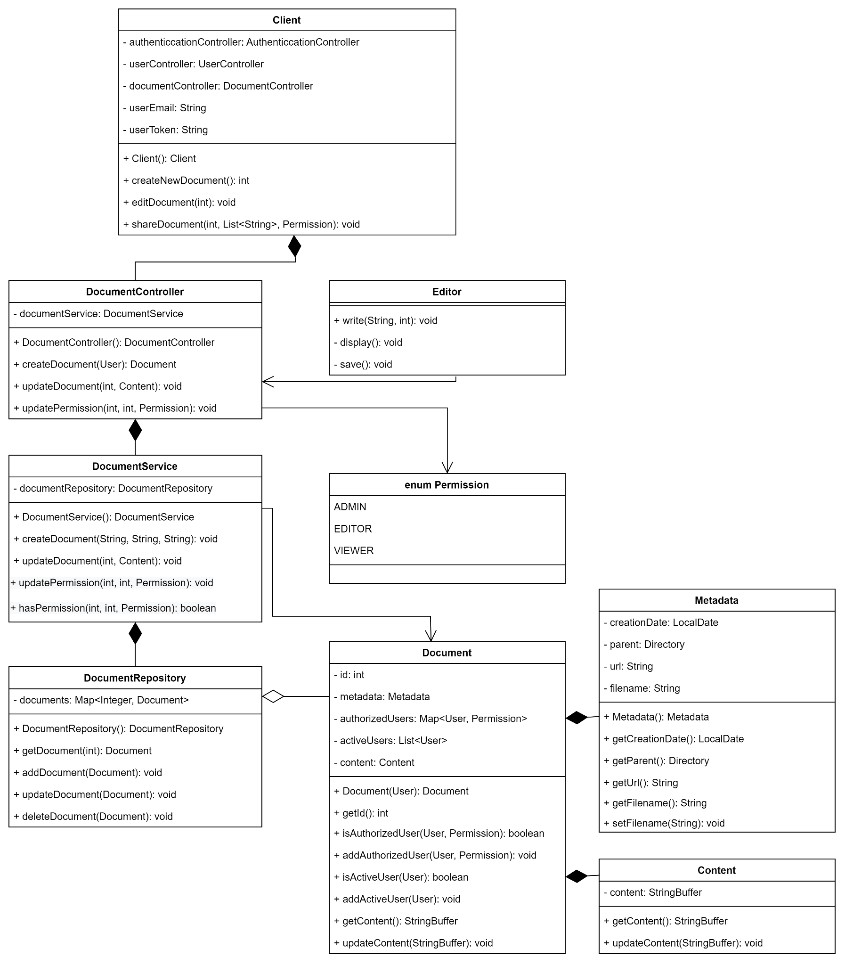

## Sketch

Users can see all active collaborators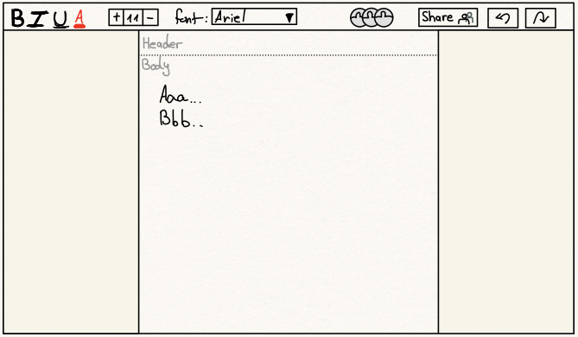

## **Mock-up**

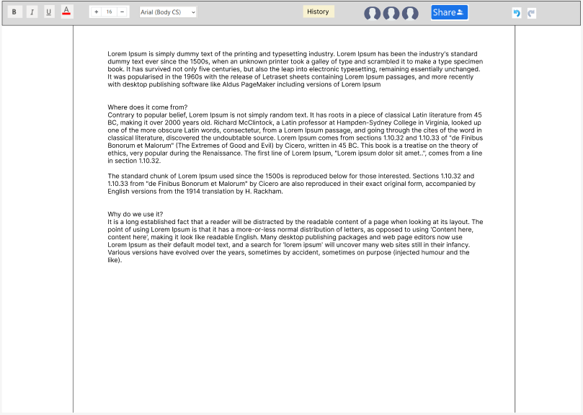

## Sequence diagram

[sequence diagram](https://app.diagrams.net/?state=%7B%22ids%22:%5B%221HyGbJLpUlVGSLFbTntjfDNS_HXuuenYO%22%5D,%22action%22:%22open%22,%22userId%22:%22102538424459651366570%22,%22resourceKeys%22:%7B%7D%7D)

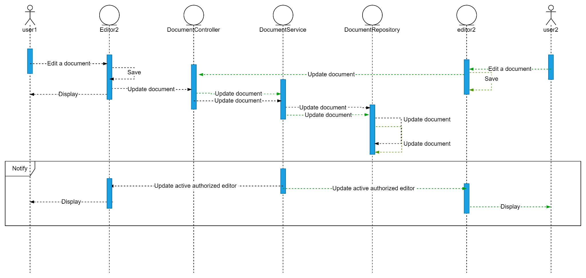

# Testing

[Testing - Edit simultaneously](https://docs.google.com/spreadsheets/d/1-zx9Vh6vEgot1eBunadwKVD1zICGvye3kXGBrmZA3uM/edit?usp=sharing)